REPORT

Date:18/05/2020

* Today, I started **AWS ALEXA** certification course provided by AWS educate. As the part of **ICT ACEDEMY** Certification course.
* I completed Module 1: Prerequisite Knowledge consisting of two chapters named below

1)Module 1.1: Prerequisite Knowledge - S3

2)[Module 1.2: Prerequisite Knowledge - Lambda](https://awseducate.instructure.com/courses/175/modules/items/3947)

* Chapter 1 consists some fundamental prerequisite knowledge which is foundation for requisite technical knowledge. 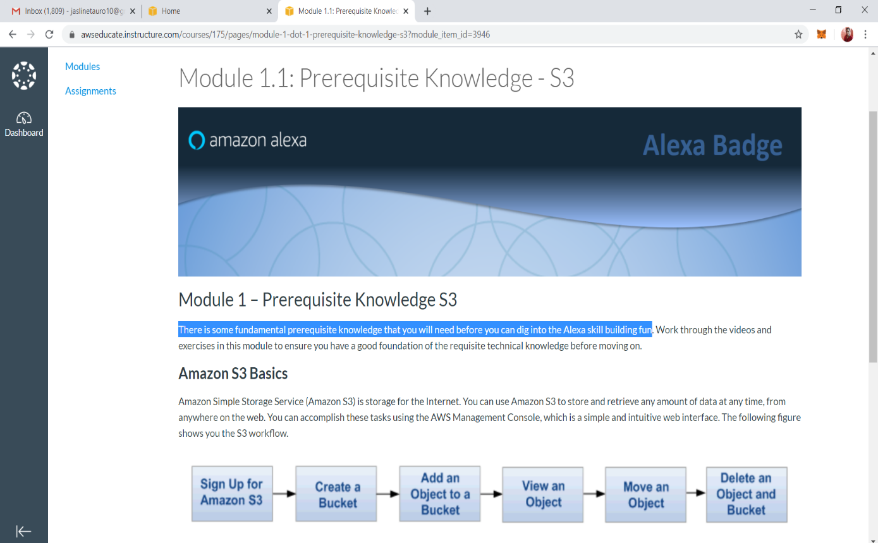
* Chapter 2 consists of basis knowledge of AWS Lambda

